# Dissertation Title

# Coworking Office Space

## Name of the Group members

## Dev Sampat – 17030122057

## Mukul Thakkar – 17030122070

## Aniket Sawant – 17030122010

## Anierudh B Sundararajan - 17030122081



*Under the guidance of*

*Ms. Hema Gaikwad*

**Submitted in partial fulfillment of undergraduate Degree**

## Bachelor of Business Administration- Information technology

## BBA-IT

To

## SYMBIOSIS INSTITUTE OF COMPUTER STUDIES AND RESEARCH

**SYMBIOSIS INTERNATIONAL(DEEMED UNIVERSITY)** September 2019

SYMBIOSIS INSTITUTE OF COMPUTER STUDIES AND RESEARCH

CO-WORKING OFFICE SPACES

TABLE

Acknowledgement

Declaration

Certificate of Institute (Refer last page)

List of tables

List of Figures

Abstract

|  |  |  |
| --- | --- | --- |
| S.NO | DETAIL | PAGE NO. |
| 1.  2.  3.  4.  5.  6.  7.  8.  9.  10.  11. | Introduction  Literature Review/ Need Analysis/ Requirement Gathering 11   * + Project profile   + Existing System   + Problems faced by users   Problem Formulation   * + Objectives of Proposed System   + Scope of the proposed system   + Feasibility study   + H/W & S/W requirements   Proposed Methodology   * + Use cases/ERD/table structure/wireframes     Summary of Dissertation Work  SEM 6 WORK  Database Tables  Input Screens  Test Plan and Test Cases  Conclusion  Plagiarism Report  References |  |

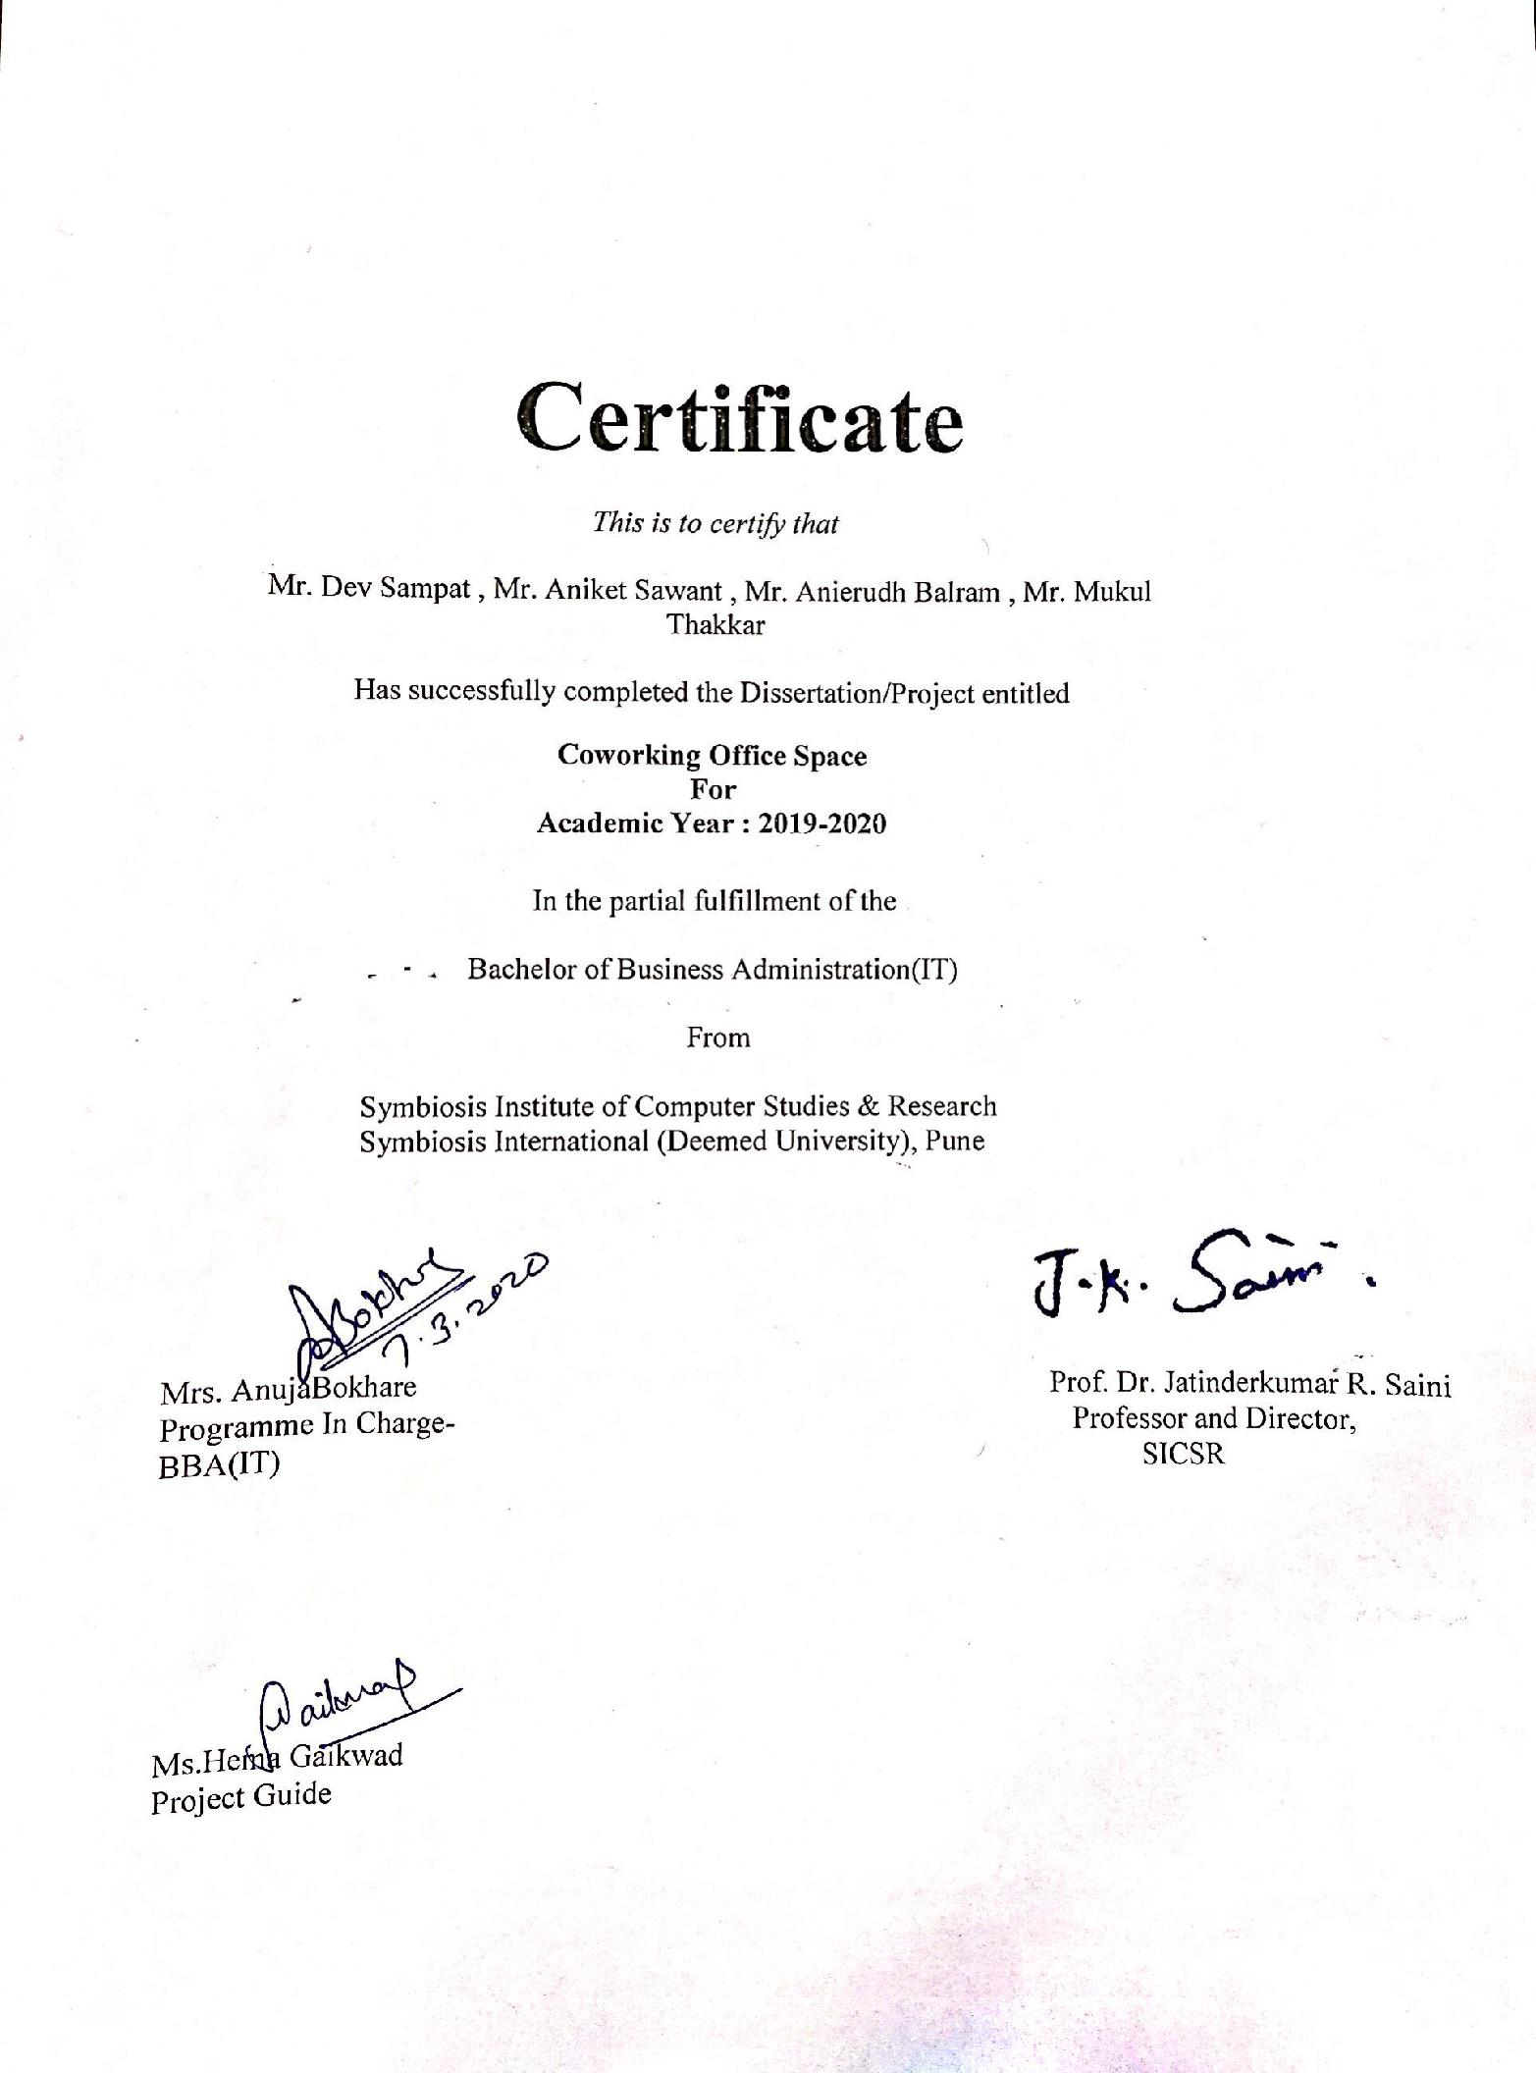

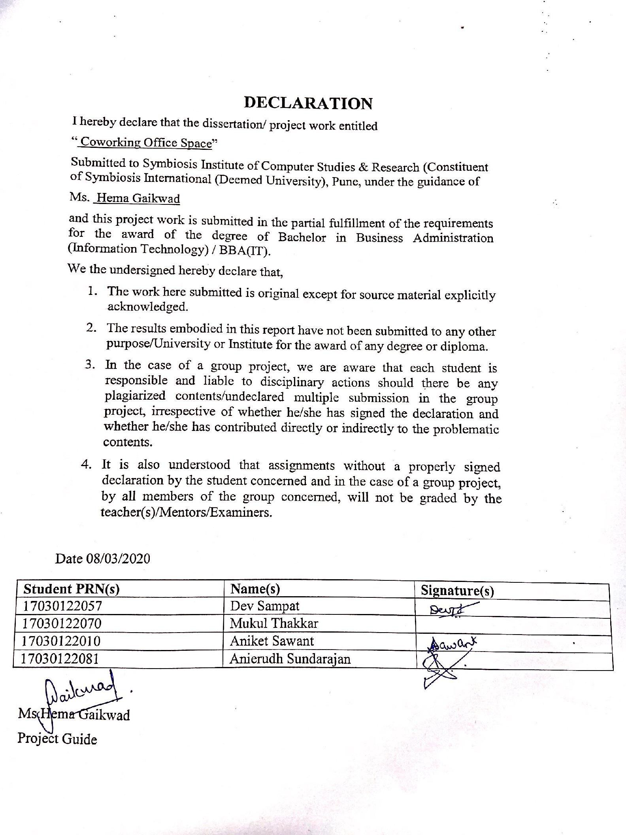

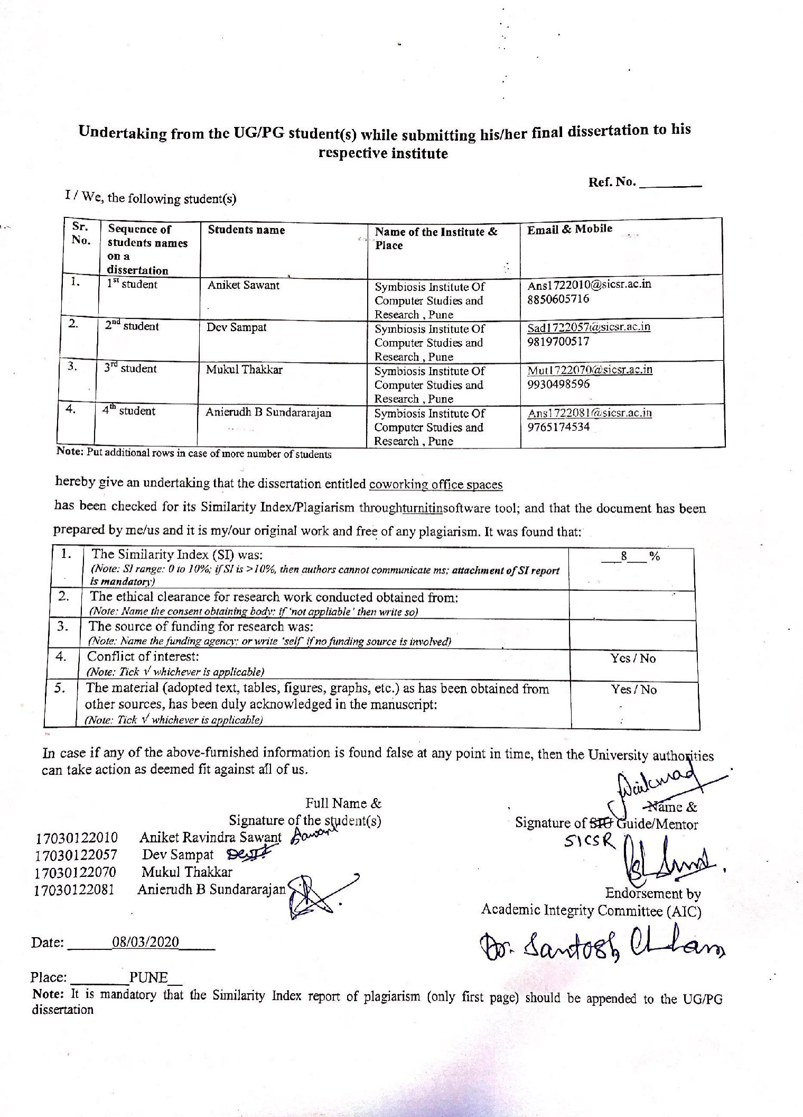

# List of Tables

1. Literature Review Research Analysis
2. Literature Review Links

# List of Figures

|  |  |
| --- | --- |
| Sr. No. | Name |
| 1 | Swimlane Diagram |
| 2 | ER Diagram |
| 3 | Data Flow Diagram |
| 4 | Customer Registration Form |
| 5 | Payment Form |
| 6 | Admin Login |
| 7 | Customer Login |

# Abstract

The key feature of this organization is to provide working space for the people who do not have space to work but want to do something for themselves, so it would lead to more self-employed people and increase the self-employment rate.

# Introduction

There are many people who are capable of doing something great but don’t have the amenities to do it either they can’t do it because of their surroundings at home or because of the lack of resources like money space for working. So, the suggestion is that the people can work at a single place at hourly-weekly-monthly basis at a cheaper affordable rate, how does this work?

People who come visit the site have to choose their day timings and according to the available slot they will get their place there will be different kind of amenities available for different kind of bookings Ac, Non-Ac , A personal cabin, so they will have these options to choose upon and the people for monthly basis would get lockers for their materials to keep, and it will be a 24/7 serviceable office.

**Literature Review**

|  |  |  |  |  |  |
| --- | --- | --- | --- | --- | --- |
| PAPER CODE | AUTHOR NAME | JOURNAL NAME AND YEAR | TITLE | SUMMARY | CONCLUSION |
| 1 |  |  |  | The key aim of the following paper is to view and understand the idea of coworking from the view point of verifying all ideas based on this this concept and to display the problems for theoretical improvement. Especially, first an overview is published on practical understanding of coworking, which is the main concern of rising attention in Japan and the rest of the world in the coming years. | This document has proven to throw some useful insights on co working but while getting more and more attention in Japan and the rest of the world in the forecoming years has gone through hardly any theoretical challenges. We can conclude that, coworking should be more specific and systematic and should be on the basis of 2 ideas of coworker, |
| 2 |  |  |  | The people who choose co working over the recent few years and also the number of office spaces in India and the rest of the world increased at a very constant rate , with an expectation of doubling the numbers in the future . We can say that coworking spaces are generally chosen by the creative class, because they are responsible for community of work which makes sharing of culture an easy task. | Based on the actual facts and figures the no. of Co-Working spaces in India by the end of 2015 were 6000 .  Because of the variations in labour market in the recent years and recorded a humongous rise in quality work .We can conclude that the people who are part of creative class are increasing in number showing resistance towards work in bureaucracies that creates innovations and creativity. |
| 3 |  |  |  | This document lets you to gain more understanding of co-working spaces based on workplace management and their usability . The extent of workplace development has spread across across the city and the country . We can say that it has resulted in increasing common in workplace practice and research. Moreover , the function of workplace usability is now more of a generalized topic . | This dissertation study aimed to develop the understanding of the co working space concept from the viewpoint of workplace and workplace usability or user experience . Co working spaces represent one of the latest forms of multi tenant offices. They respond to the workplace user needs generated by the shift toward more mobile, collaborative, adaptable and constantly evolving . These new offices aim to support today's knowledge workers work in the best possible way , as well as to communicate the organisation's strategy to space users. |
| 4 |  |  |  | .An organization’s success is directly co-related to the performance of its people. Over time we have seen change in working pattern and working environment. From Conventional closed offices to the open plan offices to co-working spaces of today there is change in working environment. The majority of this is being done to encourage the workers and increase their efficiency. Co-working spaces helps for the smooth flow of communication in the workplace . This can be a main factor for employee satisfaction and increases the effectiveness of the work . | This paper is aimed at the alarming numbers of co-working office space as it is very dynamic and adapt to changes efficiently and effectively . This paper studied and concluded strategies which co-working spaces practice for the smooth interaction and increase innovation. Earlier days work implied that many employees go to co-working spaces to join a community or to access a network which can be important for their business. Yet, both literature and our evidence suggest that co-locating people does not automatically lead to interaction nor to innovation. |
| 5 |  |  |  | Based on the current economy the work done is more knowledge oriented and leads to innovation especially in urban centres. Through this research we can understand how the function of co-working is important for the development of local economy of mid-sized cities. Based on the necessary insights we can understand how change in economy is playing is handled in these cities . | With the recent understanding cities are nowadays leading to innovation and creativity. urban coworking movement that is supporting a new generation of knowledge workers. They provide cost effecient, with best in class features. By providing services that leads to increase effectivity of the busin ess and establish relationships. coworking helps in organizing labour in the 21st century |
| 6 |  |  |  | Cooperating spaces are a quickly developing component of ongoing urban communities, and progressively in vogue consultants, information laborers, fire up networks, and othersengaged in non-standard innovative urban work. Drawing on ethnographic datagathered during a curiously large contextual investigation of collaborating spaces in Australia, we create aneconomic model of an indispensable part of cooperating spaces, thus the economiclogic of their reality, during which a collaborating space could likewise be a Schelling point. Thisargues that the principal edge helpful a collaborating space gives isn't pricecompetition overhauled workplaces, or a more wonderful condition than working athome, however as a central (Schelling) point for finding individuals, thoughts and other resourceswhen you do not have the information essential for coordination | The ascent of collaborating spaces far and wide has been broadly noted yet hasgenerated little enthusiasm for financial aspects past the perception this gives off an impression of being unfurling of separated item specialties in the urban office rental market. Butwe have proposed here an elective model contending that an in a general sense neweconomic wonder can be seen in which cooperating spaces are betterunderstood as what we call 'social economy Schelling focuses' inside the evolvinglandscape of new spaces for urban creation. Right now, spaces become innovatively built central purposes of implicit coordination betweenniche entertainers who envision finding each other at these areas all together tocooperate on joint ventures. In any case, the basic factor is that this developing participation |
| 7 |  |  |  | Portable experts can decide to work in workplaces, official suites, home workplaces, or different spaces. Be that as it may, some have rather decided to work at collaborating spaces: open-plan office conditions in which they work close by other unaffiliated experts for a charge of around $250 every month. In any case, what administration would they say they are really buying with that month to month charge? How would they depict that administration? From an action hypothesis viewpoint, what are its article, result, and on-screen characters? This article provides details regarding a 20-month study that answers such inquiries. | Right now, I have analyzed how individuals all in all characterize and decipher a new community oriented action through their discussion and their numerous writings. Collaborating is certainly not a solid item like outfitting a structure, yet an assistance—indeed, a help that owners give in a roundabout way, by giving a space where associates can arrange their different exercises by taking part in distributed cooperations. This administration is presently dubiously characterized, permitting various setups; therefore, we have seen a wide range of inconsistencies in the article, on-screen characters, and results of cooperating. In any case, cooperating has developed and will probably keep on advancing; as we inspect how, we can likewise look at suggestions for how we apply movement hypothesis to other rising community oriented exercises. |
| 8 |  |  |  | Co working spaces are shared office environments for sovereign professionals. These spaces have been increasing fast throughout the world,with every country having an outlet for the same. This article depicts social interaction in coworking spaces and reports the results of two different studies. Study 1 (N = 69 coworkers) finds that social interaction in coworking spaces can lead to social support. Study 2 further investigates social support among coworkers (N = 154 coworkers) and differs these results with those of social support among employees in traditional work organizations (N = 609). A balanced mediation model using time pressure and self-efficacy, based on the conservation of resources theory, is put it on test. Social support from both the sources was positively related to performance satisfaction and even social satisfaction upto a certain point. Self-efficacy generated this relationship in the employee sample, while in the coworking sample, self-efficacy only generated the relationship between social support and performance satisfaction if time pressure was high. Thus, a mobilization of social support seems necessary in coworking spaces. We conclude that coworking spaces, as modern social work environments, should align flexible work infrastructure with well-constructed opportunities for social support. | Right now, I have inspected how individuals by and large characterize and decipher a rising cooperative action through their discussion and their numerous writings. Collaborating is certainly not a solid item like outfitting a structure, however an assistance—truth be told, a help that owners give in a roundabout way, by giving a space where colleagues can arrange their different exercises by taking part in distributed cooperations. This administration is presently enigmatically characterized, permitting various designs; thus, we have seen a wide range of logical inconsistencies in the item, entertainers, and results of cooperating. Be that as it may, cooperating has advanced and will probably keep on developing; as we inspect how, we can likewise look at suggestions for how we apply movement hypothesis to other rising collective exercises. |
| 9 |  |  |  | Co-working office spaces developed when the home office end up being lacking for specialists, who require a beneficial, innovative, and fulfilling work environment. In an investigation about better approaches for working, Fraunhofer IAO, in Stuttgart, Germany, discovered that cooperating can possibly change the universe of information work. Collaborating isn't only for specialists and new businesses. An ever increasing number of companies have just begun to understand that collaborating offers extraordinary potential for cultivating advancement. In any case, where are the foundations of this potential? How might they be moved to various kinds of organizations? | he most recent few years, expanding quantities of free experts have picked to work in cooperating spaces. This rising office type seems to give a creative situation to this specific objective gathering since it gives chances to social help notwithstanding adaptable business foundation. Until this point, just a couple of logical examinations of cooperating spaces have been directed. Our subsequent examination is, as far as we could possibly know, the first to quantitatively explore social help in collaborating spaces across Europe. The discoveries feature the significance of associates as a wellspring of social help among autonomous experts and ought to empower considers that further investigate collaborating spaces as a social office condition prone to become considerably more in the future. |
| 10 | SIGRID G. ZIALCITA , KAPIL KANALA | ASIA PACIFIC COWORKING TRENDS | Co Working Office Space | Coworking spaces provide business solution to individuals, proving to be a long lasting trend and displaying one of the main changes in the work environment today. With memberships increasing at an alarming rate @ which is more than a global avg of 40% . coworking operators have been an important demand catalyst across Asia Pacific. Coworking across asia pacific , spans more than 8 million sq. ft. | The commercialization of coworking spaces have revolutionized the real estate .Its flexibility, negligible capex costs and promises of increased collaboration and networking benefits have firmly etched the concept into corporate real estate strategy. One of main challenge is that how these strategies are incorporated in the practical situation is very important . |

# Problem Formulation

Rising importance of Co-Working office spaces and its impacts.

# Proposed Methodology

**Motivation**

We mainly chose this topic to emphasize the increasing importance of co working office spaces in India. It helps to reduce costs and also it’s very flexible in nature.

Also it’s very helpful in separating work from home. It leads to less office expenditure. It has a unique style as they provide personal space with professional arrangements.

**Business Model**

**Swimlane Activity Diagram**

A swimlane diagram is defined as the process flow of diagrams or flowcharts which visually distinguishes job sharing and responsibilities for sub-processes of a business process. Swimlanes can be put together either in a horizontal way or a vertical way.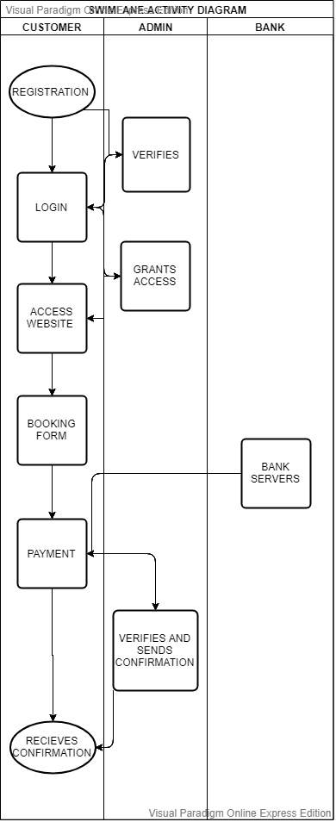

Figure 1

# Proposed Methodology

# ER Diagram

# 

Figure 2

# Data Flow Diagram Level 1

# 

Figure 3

# Input Forms

**Customer Registration**

**Name :**

**Email Address :**

**Password:**

**Confirm Password :**

**Gender: Male Female**

**Username :**

**State :**

**City :**

**Pincode :**

**Mobile No :**

**Security Question :**

**save edit add delete cancel**

Figure 4

**Payment Form**

**Full Name :**

**Customer ID :**

**Booking ID :**

**Mode Of Payment : COD Card Payment**

**Online Payment**

**save edit add delete cancel**

Figure 5

**Admin Login**

**Username :**

**Password :**

**save edit add delete cancel**

Figure 6

**Customer Login**

**Username :**

**Customer ID :**

**Password ID :**

**save edit add delete cancel**

Figure 7

# Summary Of Dissertation Work(5TH SEM)

To summarize, the up and coming coworking space will reduce the problems of new entrepreneurs and upcoming employees, etc This is because they will be able to afford a compact but feasible office space at an affordable rate. They can pick their choice of office according to their budget and requirement. Also, as they will have shared space with other employees they will also get a chance to expand their business contacts and get in the mend.

**Database Tables**

In our website , using MySql we have created 5 tables in total

* Cart
* Feedback
* Item
* Records
* Signup

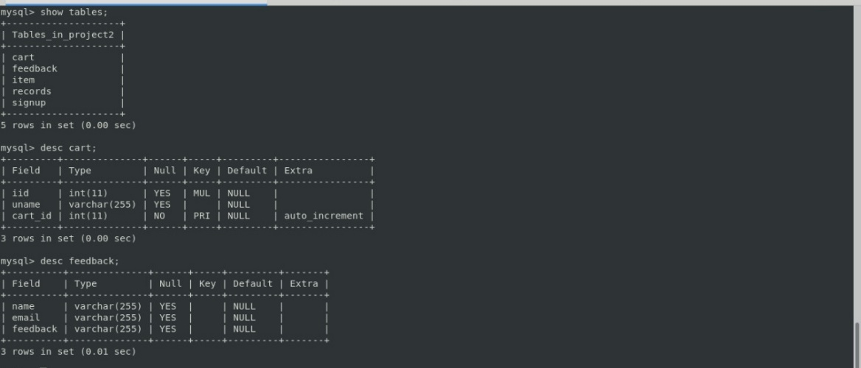

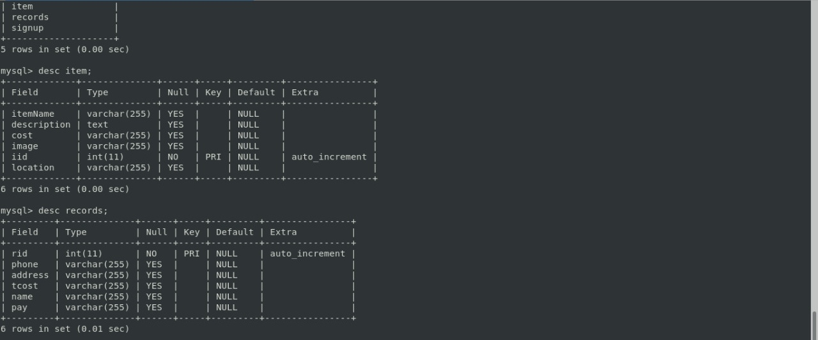

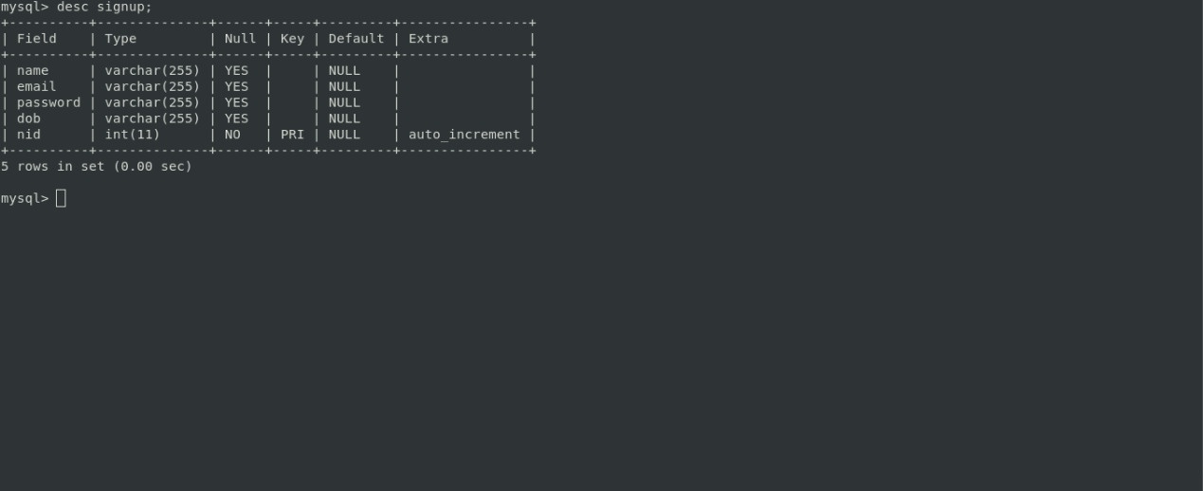

**Input Screens**

There are totally 5 Input Screens which we have used in the website for various purposes like :

* **Login Page**

Here the user is expected to enter his/her E-Mail ID and their respective password to login into the website . Incase a new user there is a signup option right below which will allow new users to register .

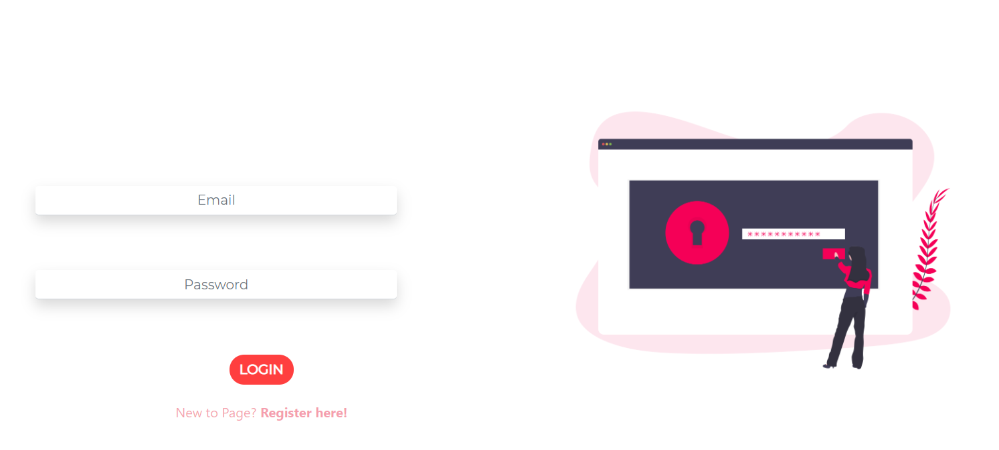

* **Signup Page**

Here the new users can easily register and sign up by creating an account using their Email ID and some other details.

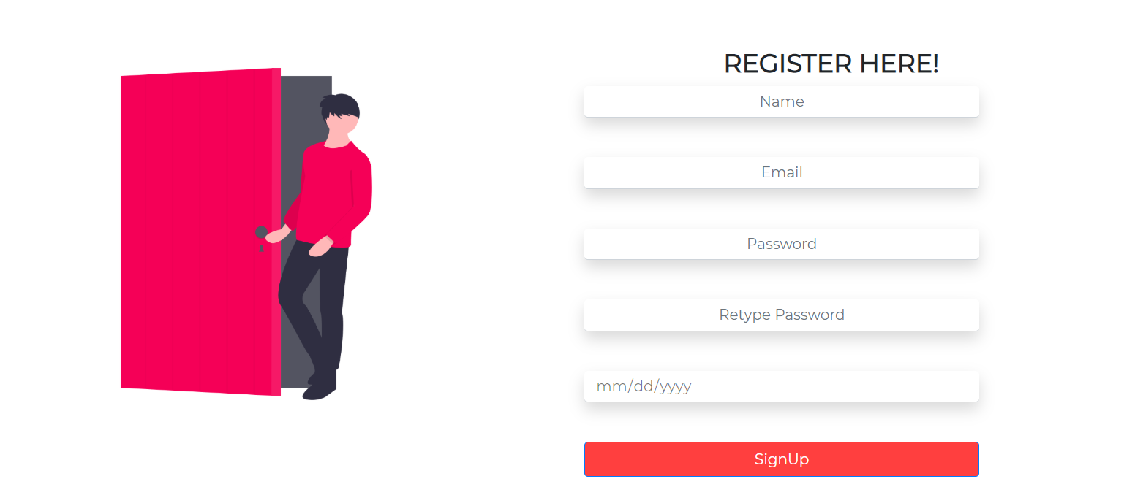

* **Admin Panel**

Here we have created a admin panel for all the admins to add products/centres along with their various information like Cost , Description , Location , Images etc.

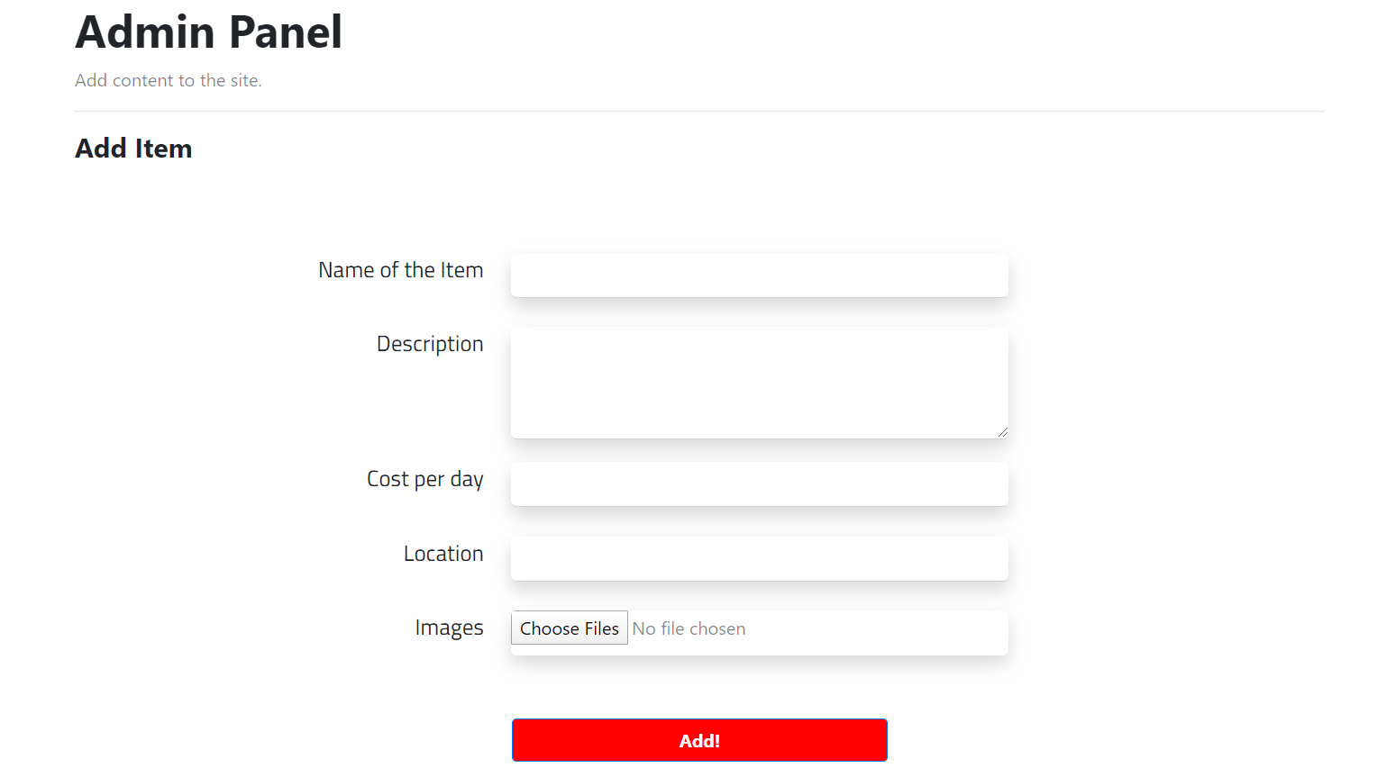

* **Contact Us**

We have also made a contact us form which lets the user give customer feedback using his E-Mail.

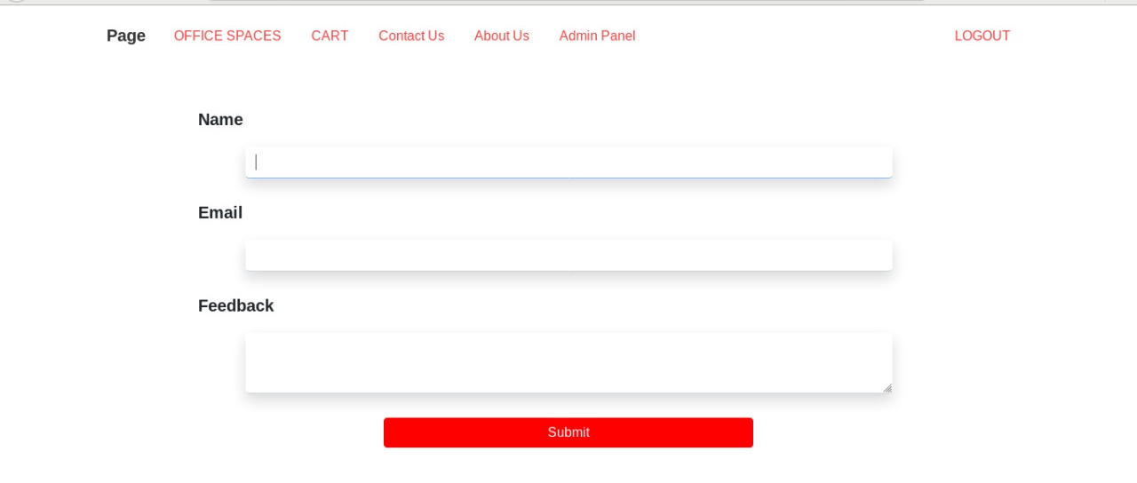

* **Location Search**

**Here based on locations a user can search centres which is comfortable for them from the list of various centres all spread across the country .**

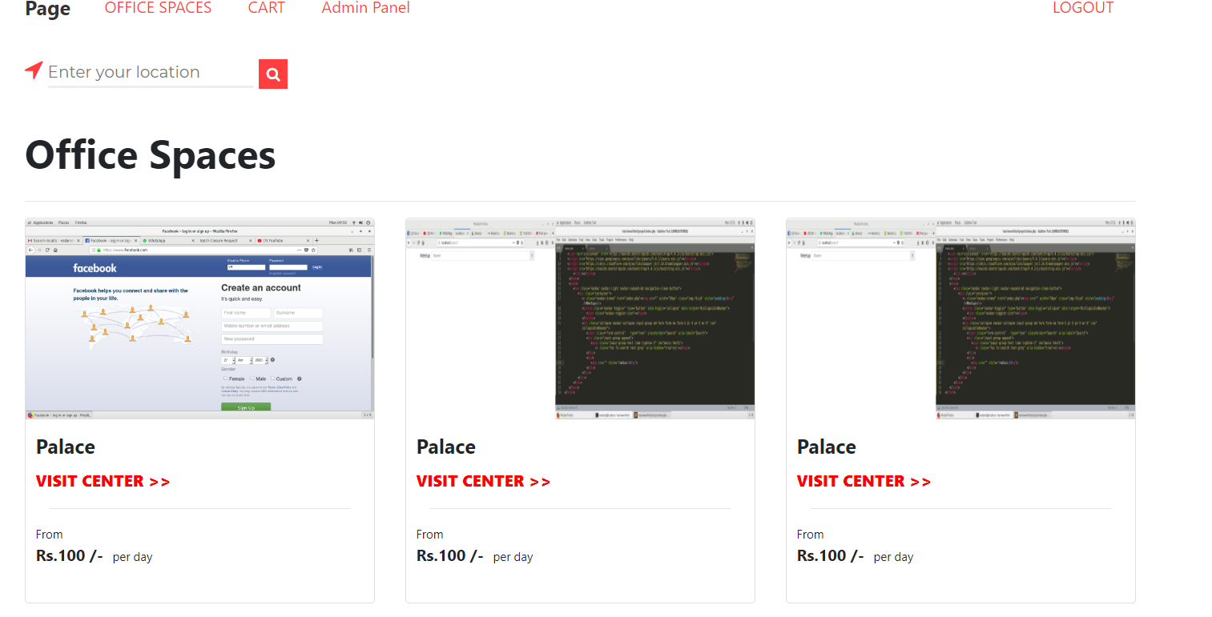

**Test Plan and Test Cases**

**Purpose**

This Test plan explains the testing activity and the overall framework that will execute the testing of Union Co-Working office spaces . It consists of :

Test Strategy : Test will be conducted based on the actual specifications like entry and the exit criteria, creation of test cases, specific tasks to perform

Test Management: The test cases, inputs and outputs, what the expected output is supposed to be and what the actual output is, the action/pre-requisites performed, whether the test case is passed/failed.

Objective : The objective is to verify all the functionalities of the website and to verify if the website is upto the specifications or not .

The test cases will also specify the severity of the functionalities and/or any defects in it.

**Test Cases**

|  |  |  |  |  |  |
| --- | --- | --- | --- | --- | --- |
| Test Case ID | Test Case Description | Test Data/Input | Expected Result | Actual Result | Pass/Fail |
| TC_01 | Open Website | <http://127.0.0.1/project2/login.php> | Login Page | Login Page | Pass |
| TC_02 | Enter Valid E-mail and Valid Password | Email ID : [admin@gmail.com](mailto:admin@gmail.com)  Password :  ******** | Homepage | Homepage | Pass |
| TC_03 | Enter Valid E-mail and Invalid Password | Email ID : [admin@gmail.com](mailto:admin@gmail.com)  Password :  ********** | Homepage | Login Unsuccesful | Fail |
| TC_04 | Enter Invalid E-mail and Valid Password | Email ID :  [invalid@gmail.com](mailto:invalid@gmail.com)  Password:  ******** | Homepage | Login Unsuccesful | Fail |
| TC_05 | Enter Invalid E-mail and Invalid Password | Email ID :  [invalid@gmail.com](mailto:invalid@gmail.com)  Password:  ***** | Homepage | Login Unsuccesful | Fail |
| TC_06 | Missing “@” while signing up with new mail | Email ID :  Invalidabc.com | Email-ID entered is invalid | Email ID entered is invalid | Pass |
| TC_07 | Click Logout | Click Logout Button | Login Page Opens | Login Page Opens | Pass |
| TC_08 | Check Office Spaces | Click Office Spaces | Displays Various Centres | Displays Various Centres | Pass |
| TC_09 | Selection of Office space | Clicks respective office space | Publishes Information and lets you add to cart | Publishes Information and lets you add to cart | Pass |
| TC_10 | Proceed to Checkout | Clicks Checkout | Checkout Page opens up | Checkout Page opens up | Pass |
| TC_11 | Viewing Admin Panel | Clicks Admin Panel | Admin Panel/Form Pops up | Admin Panel/Form Pops up | Pass |
| TC_12 | Adding images in the Admin Panel | Clicks Choose files button | Uploads the Picture in the accepted format | Uploads the Picture in the accepted format | Pass |
| TC_13 | Entering DOB while sign-up | Enter Invalid Date  01/mm/yyyy | Entered Invalid date | Entered Invalid date | Pass |
| TC_14 | Entering DOB while sign-up | Enter Valid Date  01/06/1999 | Valid Date | Valid Date | Pass |
| TC_15 | Submit Feedback | Clicks Contact us | Displays Feedback Form | Displays Feedback Form | Pass |

**Testing Strategy:**

* **Unit Testing**

It is the Level of Testing where tiny part of an individual unit / component is tested to find out if they are fit to use.

The main purpose of this activity is to verify whether units are working as per their design and handling error and exception in a more efficient way .

We divided the Project into main 5 modules

* 1. Login
  2. Sign-Up
  3. Office Spaces
  4. Checkout
  5. Admin Panel
  6. Check Out

During testing, we individually tested each and every component of the modules.

* **Integration Testing**

It is a level of software testing where individual units are adjoined together and tested as a group in whole . The extent of this level of testing is to detect faults in the interaction and the communication between integrated units.

In our website integration testing is done for office spaces and checkout modules as they are integrated together and using this testing we can discover faults in both the modules by testing each of their sub modules and easily correct and prevent them .

* **System Testing**

System Testing is a level of testing that verifies and validates the complete and fully integrated system to understand the system’s compliance with its specifications which are stated in the requirements . It takes all the components as inputs which have passed the integration testing .

In our website System Testing is done as whole to find if the website is performing all the tasks as per its requirements or not. Right from Login Page to Checkout everything is tested in order for the smooth running of the website with minimal site crashes .

**Conclusion/Summary**

Co-Working office spaces have evolved over the years drastically and have transformed ahead of the function of acting as providers of a luxirious and aminities rich workplaces . Nowadays , they act as business enablers for startups and the various MNC’s all over the world .At the same time concerns remain on security of the data , the service providers are trying to address these problems through employing extra security steps practiced in areas which were made for meeting the necessary requirement. Coworking enablers are enabling corporates and entrepreneurs to embark their focus and vision on their core competencies by reducing the load of management of the real estate . India is said to be the nation where 75% of the youngsters are indulged in Startups are below 35 years and so. Millennials are resistant to change, want luxurious work environment and a peaceful surrounding. While most of it is already in use in metro cities , co-working providers are now also getting themselves ready for expanding geographically to various rapidly changing suburbs .In future it is ecpected to see this current sector play a very heavy role in corporate real estate as well as in the start-up which will assure constant growth.

**PLAGIARISM REPORT**

cowork space1



ORIGINALITY REPORT

|  |  |  |  |  |  |  |  |
| --- | --- | --- | --- | --- | --- | --- | --- |
| 8% | | | 6% | 4% | 5% |  |  |
|  | SIMILARITY INDEX | | INTERNET SOURCES | PUBLICATIONS | STUDENT PAPERS | |  |
|  |  | |  |  |  |  |  |
|  | PRIMARY SOURCES | |  |  |  |  |  |
|  |  |  | |  |  |  |  |
|  |  | www.frontiersin.org | |  |  | 4% |  |
|  | 1 |  |  |  |
|  | Internet Source |  |  |  |  |
|  |  |  | |  |  |  |  |
|  |  | www.bartleby.com | |  |  | 1% |  |
|  | 2 |  |  |  |
|  | Internet Source |  |  |  |  |
|  |  |  | | |  |  |  |
|  |  | Submitted to Kaplan University | | |  | 1% |  |
|  | 3 |  |  |
|  | Student Paper |  |  |  |  |
|  |  |  | | |  |  |  |
|  |  | Submitted to Glasgow Clyde College | | |  | 1% |  |
|  | 4 |  |  |
|  | Student Paper |  |  |  |  |
|  |  |  | | | |  |  |
|  |  | Submitted to CSU, San Jose State University | | | | 1% |  |
|  | 5 |  |
|  | Student Paper |  |  |  |  |
|  |  |  | | | |  |  |
|  |  | Submitted to LASALLE-SIA College of the Arts | | | | <1% |  |
|  | 6 |  |
|  | Student Paper |  |  |  |  |
|  |  |  | | | |  |  |
|  |  | Submitted to Symbiosis International University | | | | <1% |  |
|  | 7 |  |
|  | Student Paper |  |  |  |  |
|  |  |  | | |  |  |  |
|  |  | Submitted to University of Hertfordshire | | |  | <1% |  |
|  | 8 |  |  |
|  | Student Paper |  |  |  |  |
|  |  |  | |  |  |  |  |
|  |  | journals.sagepub.com | |  |  | <1% |  |
|  | 9 |  |  |  |
|  | Internet Source |  |  |  |  |
|  |  |  |  |  |  |  |  |

|  |  |  |  |  |
| --- | --- | --- | --- | --- |
|  |  | hunturdeals.com | <1% |  |
|  | 10 |  |
|  | Internet Source |  |
|  |  |  |  |  |
|  |  | Submitted to London School of Economics and | <1% |  |
|  | 11 |  |
|  | Political Science |  |

**REFERENCES**

* <https://www.researchgate.net/profile/Tadashi_Uda/publication/315379628_What_is_Coworking_A_Theoretical_Study_on_the_Concept_of_Coworking/links/5a22576b0f7e9b71dd039228/What-is-Coworking-A-Theoretical-Study-on-the-Concept-of-Coworking.pdf?origin=publication_detail>
* <https://www.academia.edu/25098374/The_social_economy_of_coworking_spaces_A_focal_point_model_of_coordination>
* <https://www.ncbi.nlm.nih.gov/pmc/articles/PMC4843169/>

<https://eu.haworth.com/docs/default-source/white-papers/harnessing-the-potential-of-coworking-81444.pdf?sfvrsn=6>

* [www.cushmanwakefield.com/~/media/global-reports/Coworking-Top-Trends.pdf](http://www.cushmanwakefield.com/~/media/global-reports/Coworking-Top-Trends.pdf)
* <https://www.researchgate.net/profile/Andrej_Rus/publication/290430356_Coworking_A_Community_of_Work/links/56978bf708ae1c4279050864/Coworking-A-Community-of-Work.pdf?origin=publication_detail>